**Animatronic Face Project**

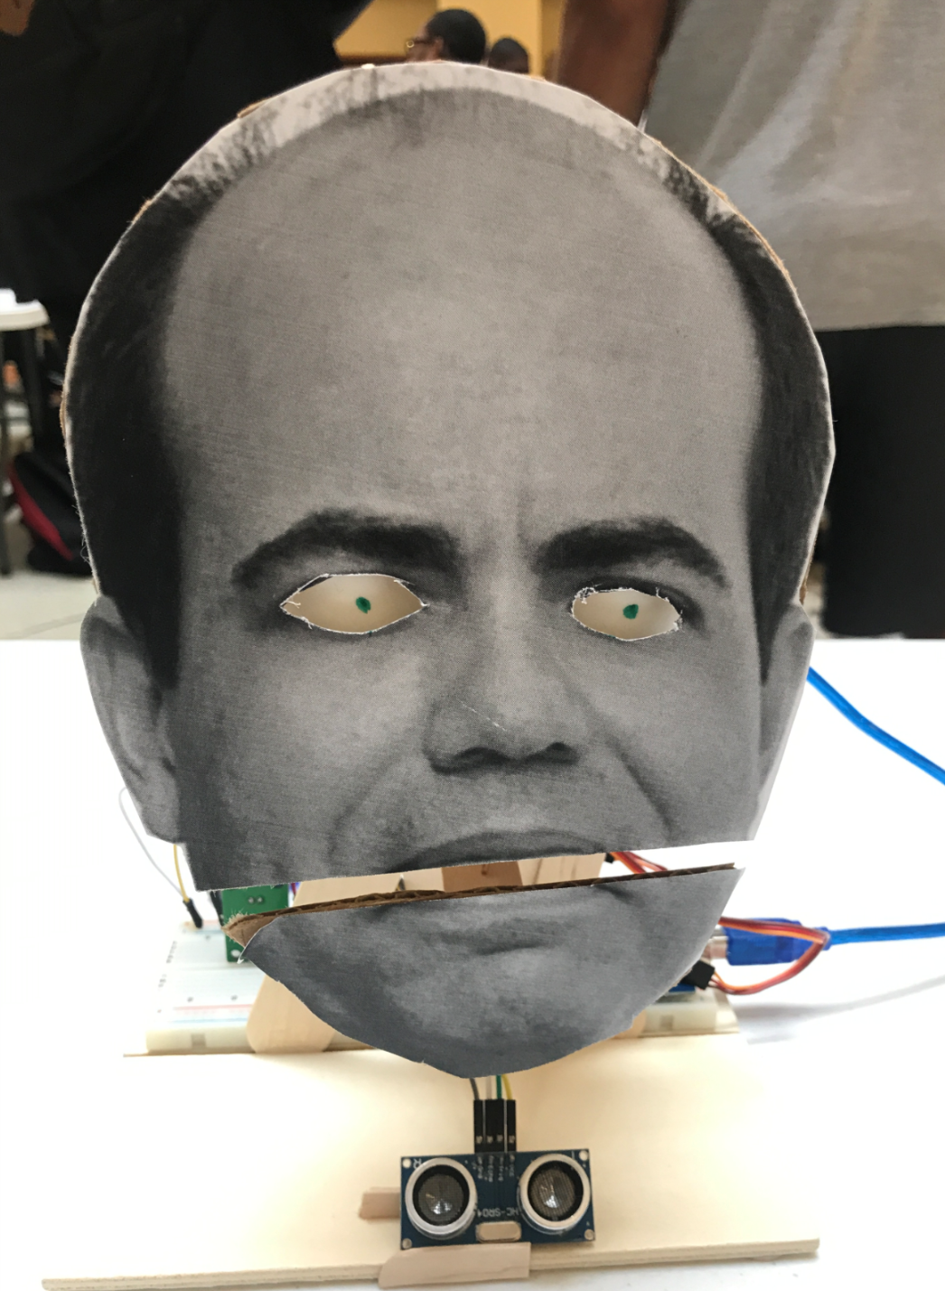

<https://youtu.be/HiW2qXimuqo>

Blake Howell

Dept. of Mechanical Engineering

San Antonio, Tx 78249

evo606@my.utsa.edu

Landon Adams

Dept. of Mechanical Engineering

San Antonio, Tx 78249

landon.james.adams@gmail.com

Stanley Nzeadibe

Dept. of Mechanical Engineering

San Antonio, Tx 78249

lkd308@my.utsa.edu

Submitted as part of project for ME4543 Mechatronics, Fall 2018

**Table of Contents**

|  |  |
| --- | --- |
| Section | Page number |
| Abstract | 1 |
| Literature Review | 2 |
| Brainstorming | 5 |
| Supporting Structure | 5 |
| Joints and Motors | 7 |
| Sensors | 8 |
| Programming | 8 |
| Lesson learnt and suggestions | 8 |
| Personnel and Bill of Materials | 9 |
| References | 10 |
| Appendix A: Code snippets | 11 |
| Appendix B: Arduino wiring | 12 |

**Abstract**

This animatronic face project was done for the Mechatronics class at UTSA. The professor that this project was based on is Dr. Finol from the UTSA engineering department. Frist, 3 concepts were researched for the design of the project and various aspects of each were taken into consideration. For the support structure we took inspiration from concept 1. Once it was determined what the animatronic face would do, we brainstormed what motors and sensors would be used. We determined that servo motors as well as a combination of sound and proximity sensors will be used. The code was written using if statements to set boundary conditions for the motors and when, or if they should function at all. Finally, this project was instrumental in teaching how to integrate different sets of code ans well as how to integrate them into a larger structure. While the project came out well, there could still be room for improvement on fine tuning the motors.

**Literature Review**

**Concept 1**

This animatronic face design was created by Chris on pyroelectro.com. It has an animatronic mouth, eyes and eyebrows as shown in Fig. 1.

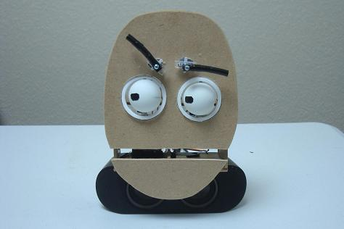

Figure 1- pyroepectro animatronic face

It was created by using standard servo motors, a PIC controller, a voltage regulator, and some jumper wires and breadboard [1]. Also, household items such as ping pong balls and carboard were used to create the aesthetic features of the face. The electronic schematic of each servo that controls the eyes, eyebrows, and mouth can be shown in Fig. 2.

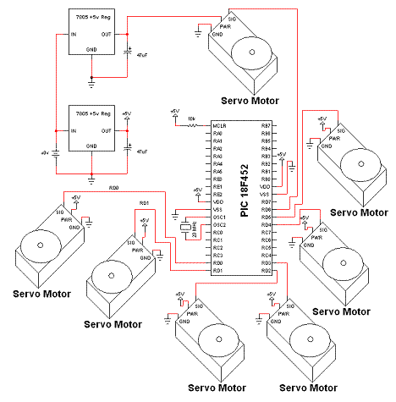

Figure 2 - electronic schematic

The idea was to move the mouth up and down, but since the servo motor moves in an angular path, the mouth movement will also do that since it follows the natural motion of the human mouth. The code used to run the mouth was a Timero Interrupt Routine which can be shown in Fig. 3.

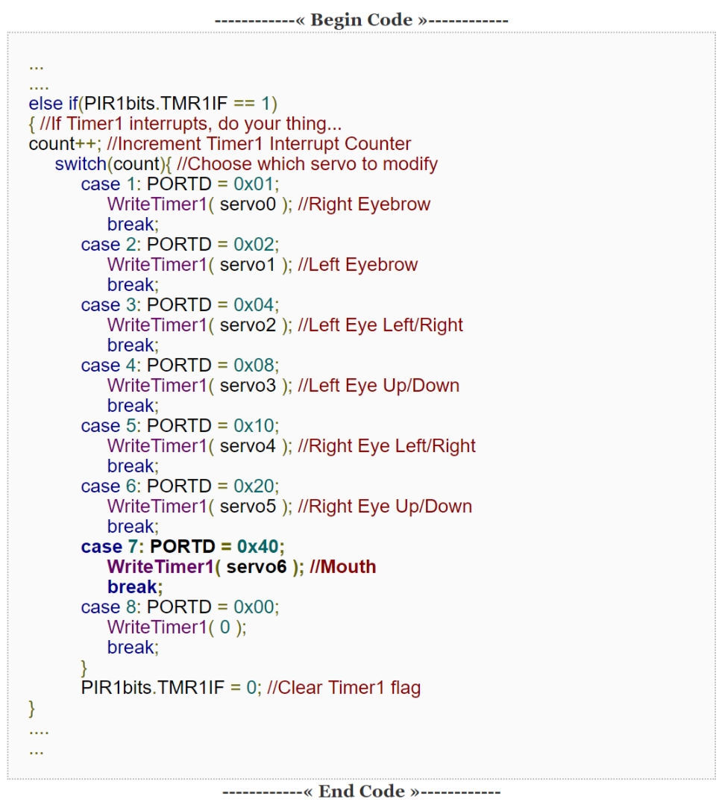

Figure 3 - controller code

As linked in reference [2], the video link shows how the finished product operates.

**Concept 2**

To build this animatronic face (Fig. 4), it needs to be broken down into the main components.

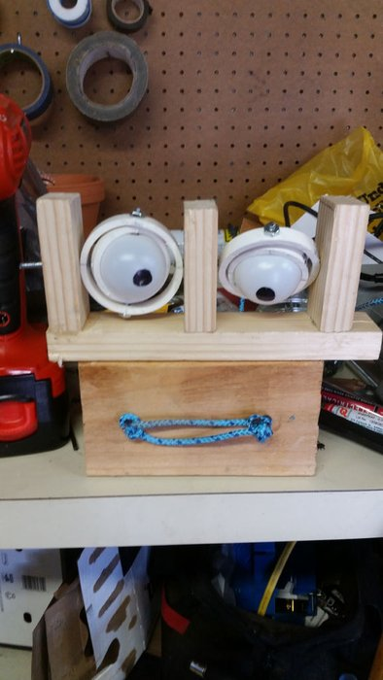

Figure 4 - concept 2 design

The first main component is the eyes. The eyes can move using 2 stepper motors on each eye. This can give the eyes independent motion in 2 directions for example up/down and left/right. The next main component is the jaw which needs to only move up and down. Since the jaw only needs to move up and down, it only needs one stepper motor to control it. To show expression the last main component is the eyebrows which as well only need to move up and down. Same as the mouth the eyebrows only need one stepper motor each. This brings the total number of motors needed to 7. The frame that this is assembled to can either be 3d-printed or made from wood (Fig 5).

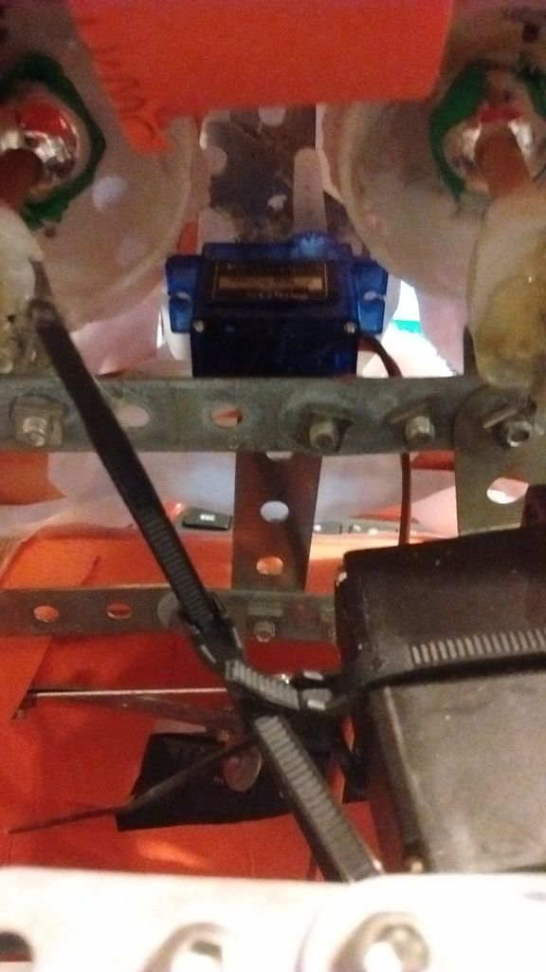

Figure 5 - concept 2 frame

Ideally 3d printing would give the best effect. To mimic the voice of the chosen professor. We must record a clip that we want to use and analyze it for high and low inflections. Once this is done the timings can be added to the Arduino code and make the motors move correctly (Fig 6) [3].

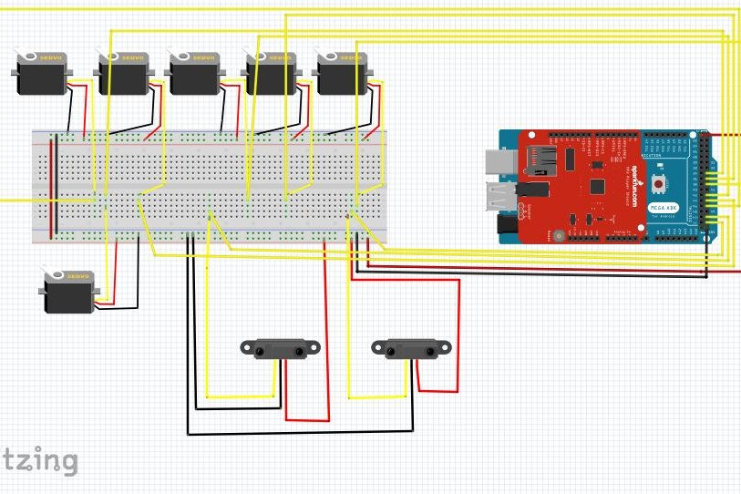

Figure 6 - concept 2 electronic schematic

**Concept 3**

An animatronic face is created as shown in the figure below (Fig.7). A frame for the mechanisms of the eyebrows, eyes, mouth, and other facial gestures will support the animatronic face. The frame will support actuator such as solenoids, servomotors, stepper motors. Springs will also be used along DC motors to control the eye position up, down, left, and right. There will be class 2 levers can be used to increase the speed of movement of facial gestures if connected between the actuator and control of facial gesture. There is a variety of mechanisms for both facial gestured and enhancement of speed. [4]

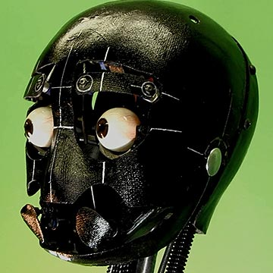

Figure 7 - Concept 3 design

**Brainstorming**

The two things that our animatronic face is going to do is have moving eyes and a moving mouth. The eyes will rotate freely around a vertical axis and be attached by a dowel rod. A servo actuator will push the eyes left or right depending on the code. Ping pong balls will be used for the eyes and dowels and crafting sticks will be used to make the structure. For the front of the face itself, carboard will be used. We will record our professors voice and move the eyes and mouth to line up with the speaking voice. The code will determine how this is used. We will use a motion sensor and sound sensor. The system will activate when there both motion and sound in front of the animatronic face. The Arduino will be powered by AA batteries and the included battery pack connector that came with a purchased Arduino kit. We plan for our professor to say.

**Supporting Structure**

The supporting structure is made with cardboard and balsa wood for the supporting base. As pictured below in the figures. The face while still not final serves as a placeholder until we can place a photo of our professor over the frame.

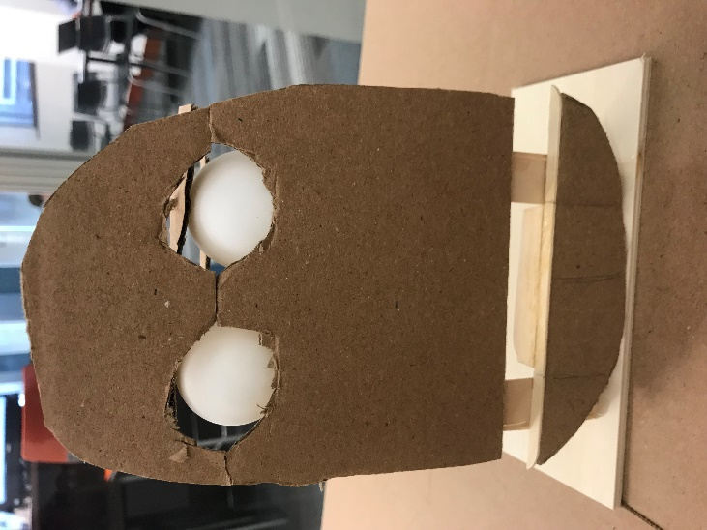

Figure 8 - animatronic face frame (front)

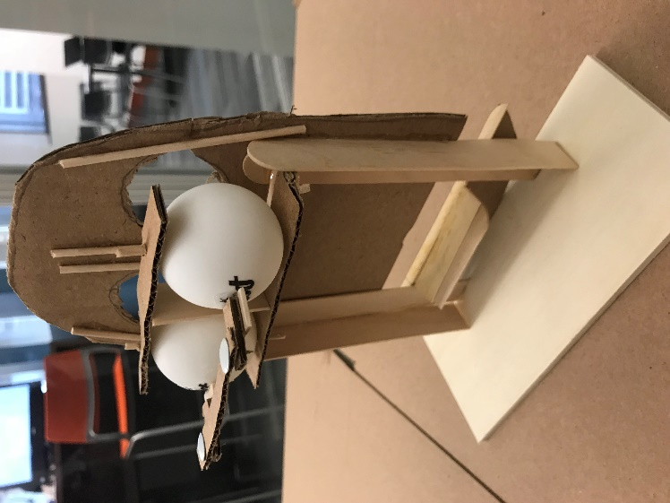

Figure 9 - animatronic face frame (back)

For the eyes, the ping pong balls were pierced with two dowel rods to serve as the axis and a supporting bar was used on a free axis so that the eyes can move left to right as shown below.

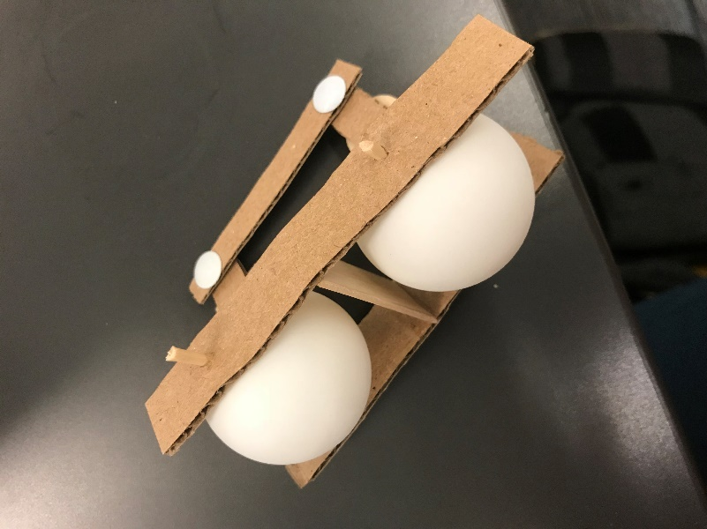

Figure 10 - animatronic face eye assembly

**Joints and Motors**

Using a slider crank mechanism we translated the rotational motion from the Arduino micro servo to linear motion. This caused the eyes to move back and forth. The mouth moved using a directly connected micro servo. We chose to use the 3V servo motor that came with Arduino mega kit. The reason for this it worked perfectly for what were trying to do. This is because it had enough force to move the mouth and the eyes. As well that it had a slow enough rotation that it make the mouth and eye movement look more fluid. Another reason was it was a material that we had already purchased in the kit. The schematics of the joints can be shown in figure 11.

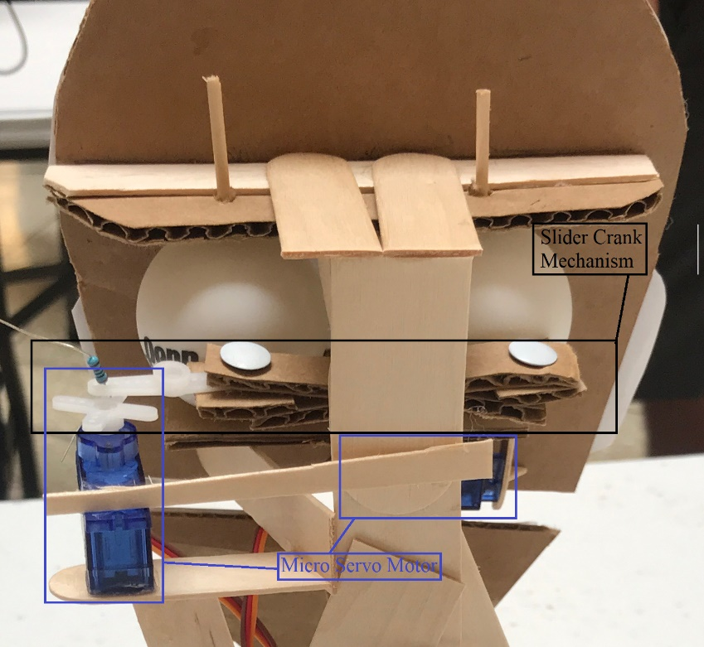

Figure 11 - joint diagram

**Sensors**

Two sensors were used for this project. The first was a proximity sensor that detects how close an object is by sending out sound waves and detecting the amount of time it takes for those waves to return to determine distance (Fig. 12). This was used to control eye movement. The other sensor used was a sound sensor that could detect the presence of sound (Fig. 13). This was used to control the movement of the mouth.

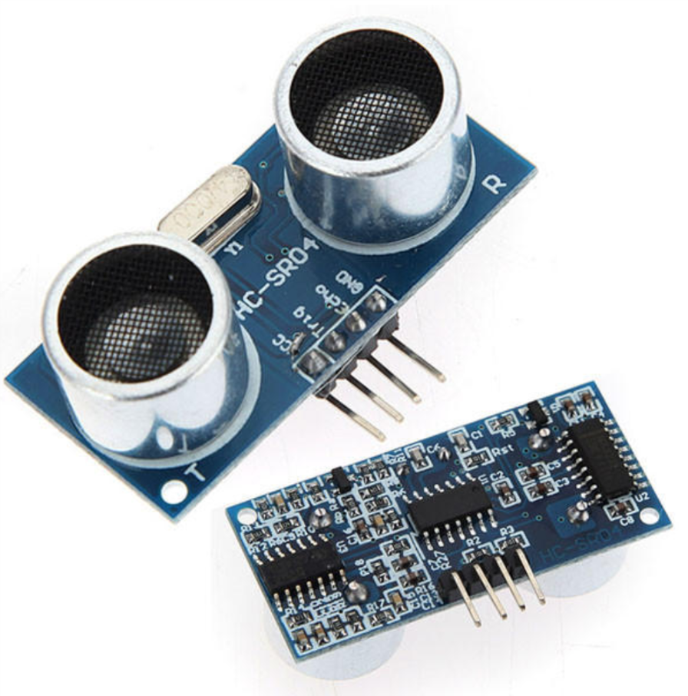

Figure 12 - proximity sensor

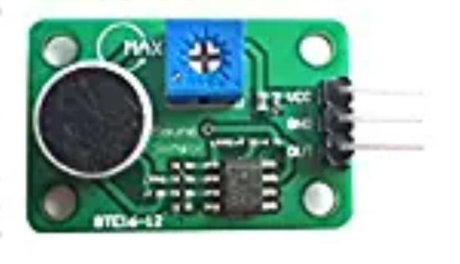

Figure 13 - sound sensor

**Programming for interaction**

The logic behind the programming to simplify things as much as possible was to write “if statements” Also to simplify things, the program continuously ran until unplugged from power. So, for the sound sensor, the “if” statement stated that if the sensor detected an analogue input above 100 then it would move the servo motor, if less than 100 it would move the motor in the other direction all with restricted angles. This allows the motor to sync to any type of audio played into sensor above a certain level. For the proximity sensor, “if” statements were used again. These stated that if the sensor value was less than or equal to 10 then the motor would stop moving. In this case, the eyes ceased to move when an object was close to the sensor. Otherwise the eyes move constantly. The programming code and Arduino diagram can be found in Appendix A and B respectively. A demonstration of how the final project works can be found in this link: <https://youtu.be/HiW2qXimuqo>

**Lessons Learned and suggestions**

1. Finding two different types of sensors was not easy to do in terms of providing two different ways of moving facial features. Looking for the right type of sensors were difficult, but we were able to use audio sensors to move the mouth while playing professor Finol’s voice and using the proximity sensor to move the eyes from side to side.
2. Finding the right type of motors for the movement of the mouth and the eyes were quite difficult to accomplished through different type of motors we were able to find two servomotors at first to use. With a lot of testing and programming, we realize the servomotors we acquired would not be strong enough to lift the mouth up and down good enough to receive credit for the movement of the mouth feature. We were then switched to the idea of using solenoids to move the mouth up and down as well as using solenoids to move the eyes from side to side.
3. A problem we were facing that was later solved through a lot research and studies were the arduino programming. We faced issues in finding the right code to get both the audio sensor and the proximity sensor work together

**Improvements**

1. Areas that we can improve are our fundamentals in arduino. Being more proficient in the use of the arduino application.
2. Working on building a more stable frame for the animatronic face. Having a more robust structure using the proper material for the design of the face, eyes, and mouth.

**Personal and Bill of Materials**

1. ***Personnel***

|  |  |  |
| --- | --- | --- |
| Task | Main Personnel | Secondary personnel |
| Structure/Chassis Design | Landon | Stanley |
| Creating joints &  Motor Interfacing | Landon | Blake |
| Integrating Sensors | Stanley | Landon |
| Overall Programming &  Integration | Blake | Stanley |

1. ***Bill of materials***

|  |  |  |  |  |  |
| --- | --- | --- | --- | --- | --- |
| No. | Description | Website/comment | Qty. | Unit $ | Total $ |
| 1 | Arduino MEGA 2560 Kit | Elegoo EL-KIT-008 Mega 2560 Project The Most Complete Ultimate Starter Kit w/TUTORIAL for Arduino UNO Nano | 1 | $54.99 | $54.99 |
| 2 | Micro Servo Motor | https://www.adafruit.com/product/169?gclid=Cj0KCQiA6JjgBRDbARIsANfu58EUGvfr4_0-WolnMvQkEo9XEBaYez5N_VVPwzfpTYDFZLOCCPkCXOsaApG6EALw_wcB | 1 | $5.95 | $5.95 |
| 3 | Wood | Popsicle Stick and Base | 1 | $15 | $15 |
| 4 | Box | Small Box | 1 | $1.79 | $1.79 |
|  | Total | Estimated |  |  | $77.73 |

**References**

[1]http://www.pyroelectro.com/tutorials/animatronic_mouths/index.html

[2]https://www.youtube.com/watch?v=KgCbQvBw-Bc

[3]https://www.instructables.com/id/RomoBOT-Animatronic-Face-Robot/

[4]https://www.researchgate.net/publication/228712974_Animatronics_and_Emotional_Face_Displays_of_Robots

**Appendix**

Appendix A – Arduino Code

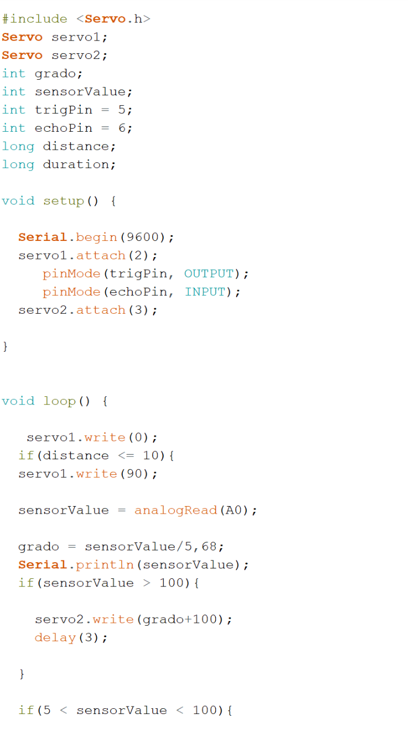

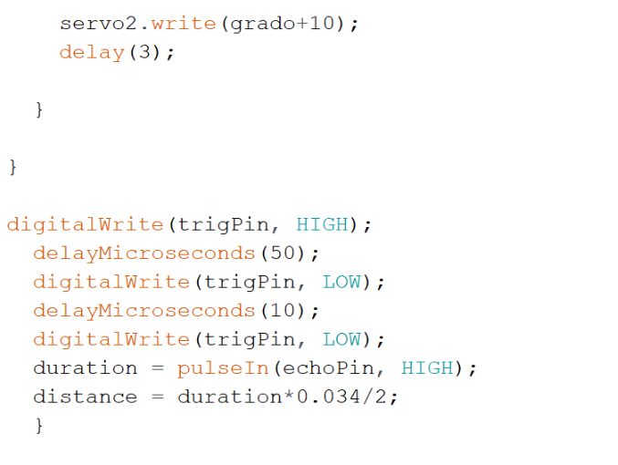

Appendix B – Wiring Diagram

